**AUTOMATED STUDENT RESULTS PROCESSING SYSTEM**

**ABSTRACT**

The technological development and impact of computers and internet on our lives that has been verified over time affected various sectors of activity. And almost every task today is being run through computers. Getting information and quickly turning it into a product that consumers want is the essential key to staying in business and all of this is done nowadays using computers and applications or information systems. And the education system is undeniably the backbone of the society, it focuses at preparing the young talents for the future. However, currently the process of AUTOMATED STUDENT RESULTS PROCESSING SYSTEM’ at the Ghana-India Kofi Annan Centre of Excellence in ICT is performed manually with extensive human intervention, the students’ results are generated through a spreadsheet application and then printed on a paper and then stored. The current research aims at creating a web based automated student results processing system, reducing time, effort and improving security. The methodology adopted for the research is based on qualitative study. The research results in the development of a multi-user system, based on web technology with MVC (Model-View-Controller) architectural pattern and developed using Java programming language with Apache Tomcat Server and MySQL Database support.

**FOREWORD**

The AUTOMATED STUDENT RESULTS PROCESSING SYSTEM is a technological system that automatically compute student scores into GRADES, reduces human error, thereby improving work accuracy, quick delivery and easy accessible of results and finally, printing of results for further use or download as a PDF file.

This system is a web based software which can be access easily anywhere. This will enable students check their results from which ever device they want to. The system also reduces burden on lecturers and administrators because of the tiresome process of manually collecting the results, marking them and computing the scores of the student into grades. However, the AUTOMATED STUDENT RESULTS PROCESSING SYSTEM eliminates all these problems and saves the results from any human errors or damages.

**PROBLEM DEFINITION**

Currently, the process of declaring and managing the students’ results at the Ghana-India Kofi Annan Centre of Excellence in ICT is performed manually with extensive human intervention. The students’ results are generated through a spreadsheet application and then printed on a paper, attached to a wall for declaration and then stored. Despite having an application that generates the result, it is not very effective as the system consumes a lot of time and human resources in performing various tasks, it is costly, it lacks data security and efficiency. And at present, the institution needs an advanced and computerized environment. And once implemented, it will minimize all the problems mentioned.

***PROJECT SCOPE***

*The study aims at developing and implementing a web-based automated student results processing system for the Ghana-India Kofi Annan Centre of Excellence in ICT, replacing the old manually done paper work and to minimize the security issues and the problems it possesses. The proposed is a multi-user system, developed using Java programming language with Apache Tomcat Server and MySQL DBMS (Database Management System) support. The system is confined to and intended for the students. They possess privileges to check their results after he/she is provided with a specific username and password for a secure login. The entire system is managed by a system administrator, who possesses the full control of the system, to read, write and execute the results and to assign privileges to teachers and students. And the teachers have the privilege to assign the students’ marks, through which, a result will be generated automatically and each student will have access to their results only, using their respective account.*

***PROJECT SIGNIFICANCE***

The computerization of the current system will have an impact on the way the students access their results and, how it is managed and generated by the institution. The system will make the life much easier for the institution as they will be able to store data much better than how they were able to do earlier. The students will have a smart management of their results and will be able to keep track of their progress with an ease of access, from anywhere, anytime and any device that has an internet connection, and just by entering their respective credentials provided by the institution. Not only for the students, but for the instructors and the institution’s administration managing the system as well. They will be able to keep their data organized and secure. The system will allow the instructors to grade the students even from home, then automatically perform the grades calculation, and the students could easily access and print them. This avoids the instructors from doing all the work manually, and have a better work quality and management that would reduce time, human effort and errors.

***PROJECT LIMITATIONS***

1. The AUTOMATED STUDENT RESULTS PROCESSING SYSTEM is limited to only GHANA-INDIA KOFI ANNAN CENTRE OF EXCELLENCE IN ICT grading scheme.
2. The system does not have an email and SMS (Short Message Service) notifications.
3. The system does not generate certificate.
4. The system does not allow Instructors to give assignments.
5. The system does not allow students to access assignments.

***SYSTEM IMPLEMENTATION***

*A development environment refers to the mix of software tools, methods, and physical resources that an IT (Information Technology) team uses to create an information system. It’s usually easier to use an IDE (Integrated Development Environment), which uses built-in tools provided by the software vendor. And for the development of the current system, Visual Studio Code and Eclipse IDE was used which is a well-known IDE, it is free, open-source, and community-supported.*

*The implementation or coding of the proposed system was performed using Java programming language which is based on the object-oriented paradigm. It organizes the system in modules or classes within their respective packages. And has become a popular approach not only in the field of programming but for system analysis and design. The current system was implemented based on the software architecture standard, MVC (Model, View and Controller), which describes its three layers. The information flow of this system, using the MVC standard highlights in the View layer, that is, the client section where information or resources are requested from the system. The Controller layer is responsible for receiving the requests and then processing and directing them to the Model layer in charge of satisfying the request by retrieving the information from the database. Then it passes the information obtained, to the Controller which delivers the response to the View and finally displays the information to the client, through the browser.*

***PROJECT REQUIREMENT DETERMINATION***

***The following are the functional requirements of the system:***

* *The system will have two types of users: Staffs ( Director of Studies, Academic Secretary, Course Coordinator, Instructors ) and Students.*
* *The system will allow the Administrator( Academic Secretary) to register new students.*
* *The system will allow the Administrator( Academic Secretary) to manage(Update and Delete) students records.*
* *The system will allow the Administrator( Academic Secretary) to generate reports of student records and results.*
* *The system will allow the Administrator(Course Coordinator) to register new Instructors.*
* *The system will allow the Administrator(Course Coordinator) to create new courses and modules.*
* *The system will allow the Administrator(Course Coordinator) to add a specific module to a course.*
* *The system will allow the Administrator(Course Coordinator) to activate or deactivate a module.*
* *The system will allow the Administrator(Course Coordinator) to manage (Update and Delete) courses, modules, Instructors records.*
* *The system will allow the Administrator(Course Coordinator) to assign module to Instructors.*
* *The system will allow the Administrators to generate reports of Courses, Modules and Instructors records.*
* *The system will allow the Instructors to add student results based on the module handled.*
* *The system will allow the Instructors to UPDATE AND DELETE students results base on Administrator’s (Course Coordinator or Academic Secretary) authorization.*
* *The system will allow the Instructors to generate reports of student results based on the module handled.*
* *The system will allow the Director of Studies and the Academic Secretary to APPROVE student results.*
* *The system will enable the students to check their results.*
* *The system will enable the students to print their results.*
* *The system will enable the students to download results as PDF.*

**FLOW CHART OF THE AUTOMATED STUDENT RESULTS PROCESSING SYSTEM**

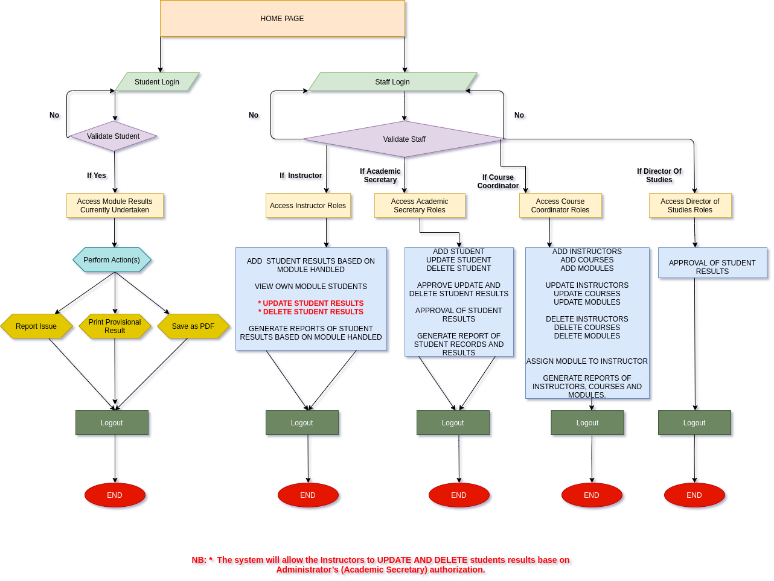

***ENTITY RELATIONSHIP DIAGRAM***

*An entity-relationship diagram (ERD) is a model that shows the logical relationships and interaction among system entities. The ER Diagram below provides an overall view of the system and a blueprint for creating the physical data structures. The following diagram displays a logical data representation of the current proposed system. Built with the help of MySQL Workbench, a visual or logical database design tool which provides data modeling, SQL development, and comprehensive administration tools for server configuration, user administration, backup, and much more.*

*The first step was to identify the entities for the current system during the analysis phase and at this stage a simplified method can be established to depict the relationships between entities. The current system database is composed of eight tables representing its respective entities, “users”, “students” , “admin”, “lecturers”, “courses”, “modules”, “results” and finally “add module to course”. And its composition can be seen in the following figure through the ERD below.*

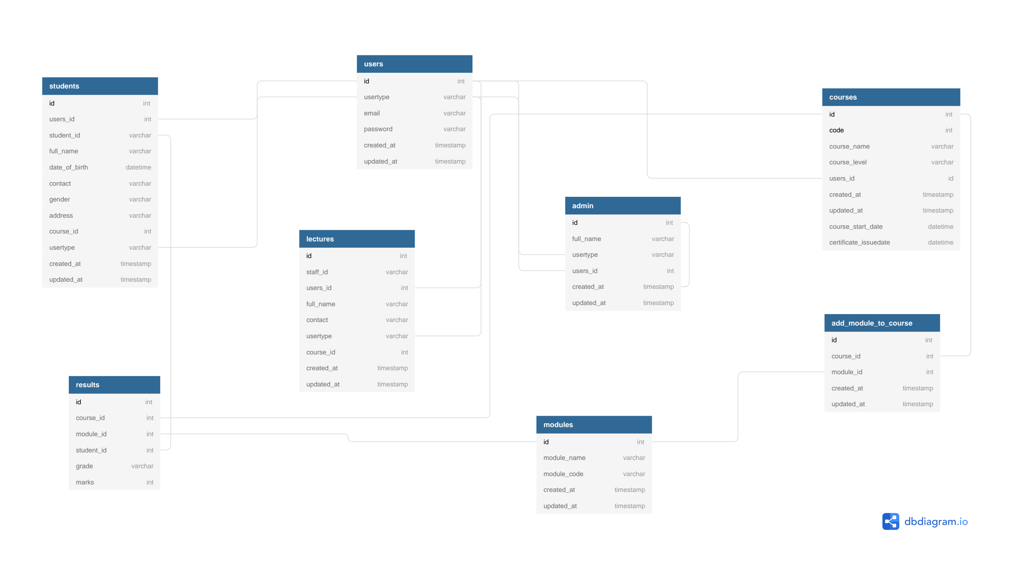

***USER INTERFACE***

Generally, the system is created around a friendly user-interface, a platform on which the users could manage the data and access the information needed. Easy to understand, manageable, reliable, interactive, that establishes a great connection with other layers of the system, manipulating the data without any inner details of it and that performs a certain task accurately. And the designing of the user-interface involved understanding the task, objectives and experience the target audience possessed. Which was possible through the application of the HTML, CSS, ANGULAR and Bootstrap technologies. Below is the first page of the system, called the home page, where the users are required to login. And the system shall open a particular account page where the user is required to be authenticated to access the system account page or dashboard according to the user level or role.

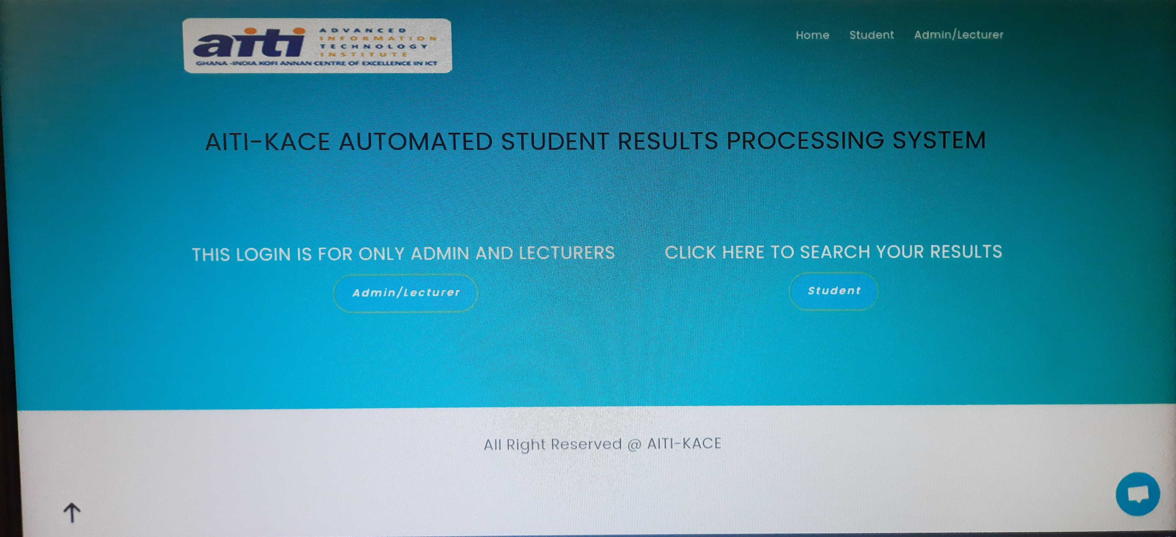

Below is the login page for the Administrator and Instructors, where the users are required to be authenticated to access the system. And the system shall open a particular account page or dashboard according to the user level or role.

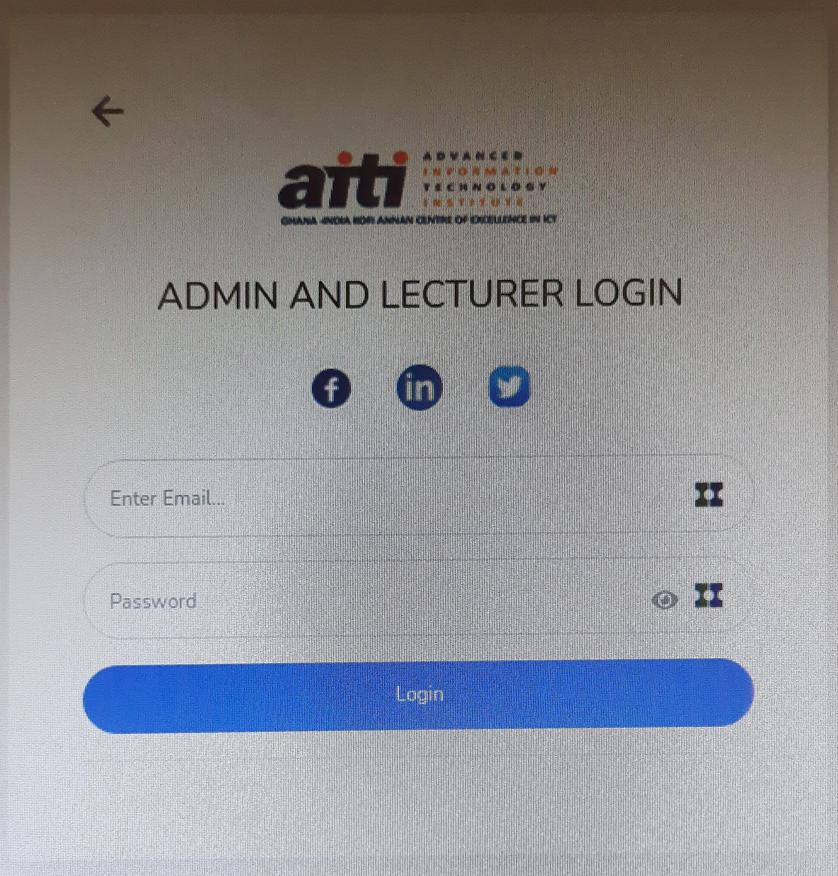

***FUTURE WORKS***

1. *The system interface could be improved, with more attractive, interactive and meaningful images.*
2. *The system will be enhance with an email and SMS (Short Message Service) notifications.*
3. We will evolve the system by developing several versions through users’ feedback, if a complete solution has not been worked out.
4. *The system will be able to generate certificate.*

***CONCLUSION***

*The present research was based on the computerization and the implementation of a sophisticated Web-Based AUTOMATED STUDENT RESULTS PROCESSING SYSTEM for the* *Ghana-India Kofi Annan Centre of Excellence in ICT. The main objective was to enhance and automate the management and declaration of students’ results using a computerized system.*

*A well-defined, efficient, controlled and managed information system or software based on web technology storing, processing and providing information through the internet. And the objectives were achieved by following a process model such as system analysis, design and system implementation.*

*The system analysis was composed of two activities, requirement determination and structuring. The first activity focused on the collection of data or requirements through structured interview, work environment observation and by collecting procedures and other written documents. And the latter, performed the modelling of the collected data and processes, transforming it into UML diagrams with the aid of a UML modelling tool which was converted into a graphically understandable manner. Just as structured analysis uses DFDs (Data Flow Diagrams) to model data and processes, systems analysts use UML to describe Object Oriented systems, on which the current system is based. UML is independent of any specific programming language and can be used to describe business processes and requirements generally.*

*Finally, the implementation or coding of the proposed system was based on the software architecture standard, MVC and SPRING BOOT using Java programming language, which is based on the object-oriented paradigm.*

***ACKNOWLEDGMENTS***

*Immense gratitude to the Ghana-India Kofi Annan Centre of Excellence in ICT (AITI-KACE). – Academic Secretary and the Faculty Department (Mr Yao ) who provided insight and greatly assisted the research and design of the system.*